MUMMY SOFTWARE CORPORATION
Store & Inventory Exercise & Training Assignment With Finance
- Sunil Malhotra has Business named Malhotra Enterprise, Ludhiana with following openings at 01-april-2019
Address: Jamalpur Colony, Metro Road
City: Ludhiana GST No.: Your GST No. Mobile: Your Mobile Email: Your Email

- Account Opening
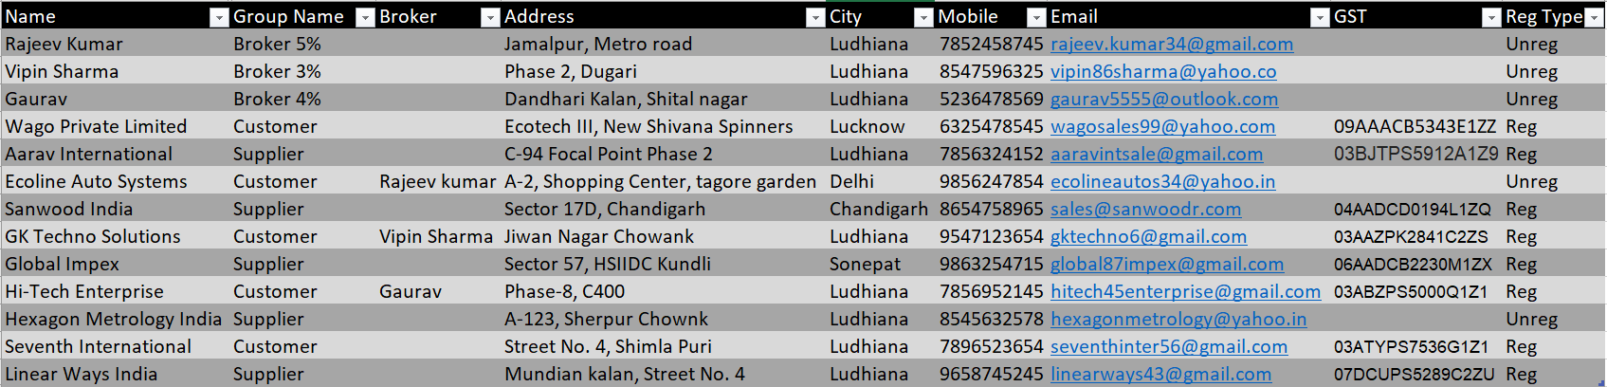

- Item Opening
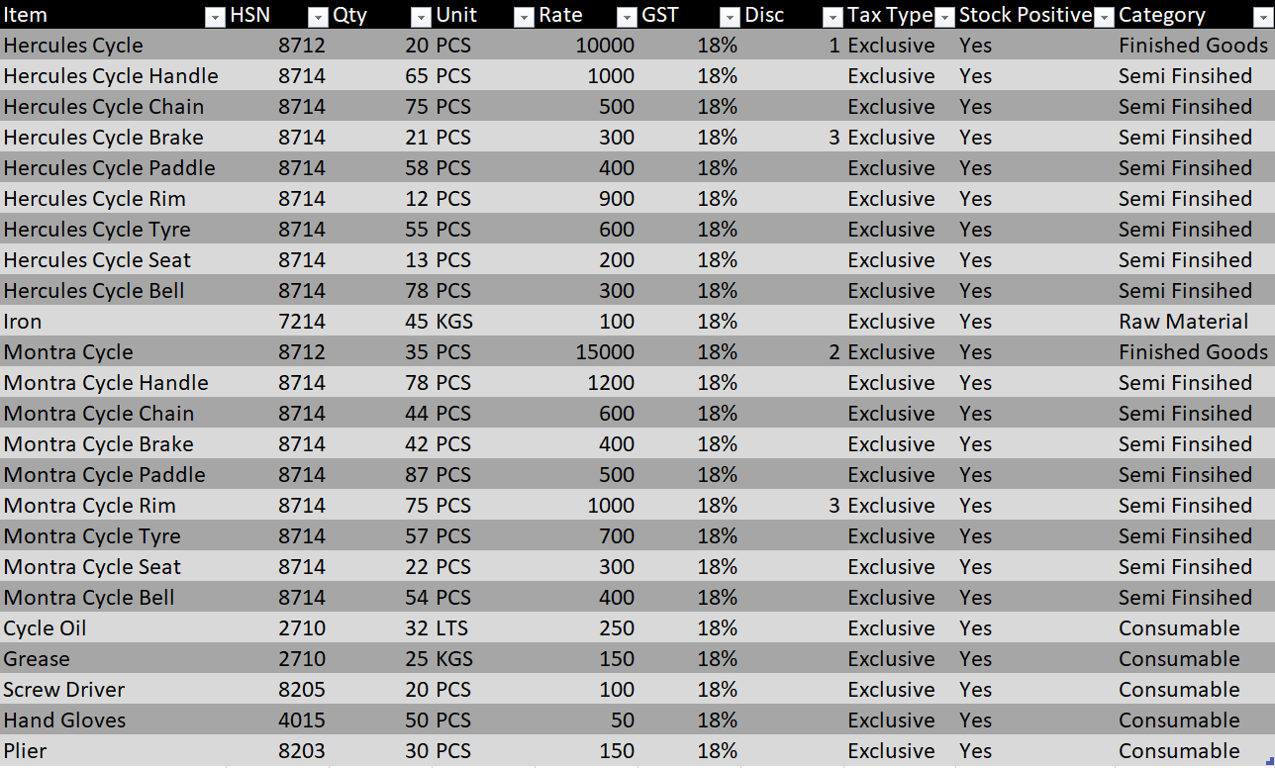
- Transactions
- Create BOM(Bill Of Material) of Hercules cycle and Montra Cycle
Hercules Cycle | Qty | Montra Cycle | Qty
Hercules Cycle Handle | 1 | Montra Cycle Handle | 1
Hercules Cycle Chain | 1 | Montra Cycle Chain | 1
Hercules Cycle Brake | 2 | Montra Cycle Brake | 2
Hercules Cycle Padel | 2 | Montra Cycle Padel | 2
Hercules Cycle Rim | 2 | Montra Cycle Rim | 2
Hercules Cycle Tyre | 2 | Montra Cycle Tyre | 2
Hercules Cycle Seat | 1 | Montra Cycle Seat | 1
Hercules Cycle Bell | 1 | Montra Cycle Bell | 1
Iron | 15 | Iron | 15
Cycle Oil | 0.3 | Cycle Oil | 0.3
Grease | 0.4 | Grease | 0.4

- Sale Order from
- Ecoline Auto Systems 2-july-2019  - Hercules Cycle 350 pcs 12000/-  - Montra Cycle 500 pcs 16000/- | HI-Tech Enterprise 3-july-2019  Hercules Cycle 200 pcs 11000/-  Montra Cycle 400 pcs 15000/-

- Check Stock If Stock is Not Available Make Work Order of
- Ecoline Auto Systems 2-july-2019  - Hercules Cycle 350 pcs  - Montra Cycle 500 pcs | HI-Tech Enterprise 3-july-2019  Hercules Cycle 200 pcs  Montra Cycle 400 pcs
(Check Material Requirement As Per Bom if Stock Not available Issue Purchase Order)
- Purchase Order To
Global Impex 3-july-2019  - Hercules Cycle Handle 750 1000/-  - Hercules Cycle Chain 750 495/-  - Hercules Cycle Brake 1580 305/-  - Hercules Cycle Paddle 1550 350/-  - Hercules Cycle Rim 1600 900/-  - Hercules Cycle Tyre 1550 550/-  - Hercules Cycle Seat 790 200/-  - Hercules Cycle Bell 730 300/- | Hexagon Metrology India 3-july-2019  Montra Cycle Handle 1330 1150  Montra Cycle Chain 1360 600  Montra Cycle Brake 2760 400  Montra Cycle Paddle 2720 500  Montra Cycle Rim 2730 990  Montra Cycle Tyre 2750 710  Montra Cycle Seat 1380 300  Montra Cycle Bell 1350 400

Linear Ways India 3-july-2019
Iron 35000 kgs 100/-
Grease 880 kgs 140/-
Cycle Oil 620 lts 260/-

- MRN(Material Receipt Note) From
Global Impex 5-july-2019  - Hercules Cycle Handle 750 10 Rej  - Hercules Cycle Chain 750  - Hercules Cycle Brake 1580 50 Rej  - Hercules Cycle Paddle 1550 15 Rej  - Hercules Cycle Rim 1600  - Hercules Cycle Tyre 1550 5 Rej  - Hercules Cycle Seat 790 25 Rej  - Hercules Cycle Bell 730 | Hexagon metrology India 4-july-2019  Montra Cycle Handle 1330 20 Rej  Montra Cycle Chain 1360 15 Rej  Montra Cycle Brake 2760  Montra Cycle Paddle 2720 40 Rej  Montra Cycle Rim 2730 35 Rej  Montra Cycle Tyre 2750  Montra Cycle Seat 1380 15 Rej  Montra Cycle Bell 1350
Linear Ways India 4-july-2019
Iron 35000 kgs 100/- 100 Rej
Grease 880 kgs 140/-
Cycle Oil 620 lts 260/- 20 Rej

- Material Issue to Core Assembly Department 5-july-2019
Hand Gloves 10 pcs
Plier 10 pcs

- Material Issue to Assembly Department 5-july-2019
Hand Gloves 10 pcs
Plier 10 pcs
Screw Driver 10 pcs

- Production Voucher as Per BOM to Assembly Department for 6-july-2019
Montra Cycle 300 pcs Process Rate: 500/-

- Material Issue to Core Assembly Department 6-july-2019
Iron 9000 kgs
Hercules Cycle Rim 1200 pcs
Hercules Cycle Tyre 1200 pcs

- Material Issue to Assembly Department 7-july-2019
Hercules Cycle Handle 600 pcs
Hercules Cycle Chain 600 pcs
Hercules Cycle Brake 1200 pcs
Hercules Cycle Paddle 1200 pcs
Hercules Cycle Seat 600 pcs
Hercules Cycle Bell 600 pcs
Grease 240 kgs
Cycle Oil 180 lts

- Mateial Receipt from Assembly Department 9-july-2019
Hercules Cycle 600 pcs
Screw Driver 2 pcs
Plier 2 pcs

- RGP Issue to Sanwood India 10-july-2019
Montra Cycle 280 pcs
Hercules Cycle 580 pcs

- RGP Receipt from Sanwood India 12-july-2019
Montra Cycle 250 pcs process rate : 250/-
Hercules Cycle 550 pcs process rate : 200/-

- Dispatch to Ecoline Auto Systems 13-july-2019
Montra Cycle 150 pcs
Hercules Cycle 350 pcs
- Dispatch to HI-Tech Enterprise 14-july-2019
Montra Cycle 100 pcs
Hercules Cycle 200 pcs

- Reporting
- Check the Purchase Register Report.
- Check Purchase Order pending Report.
- Check Production Reports.
- Check Consumption reports.
- Check Work Order Pending Reports.
- Check RGP reports.
- Check Dispatch Register.
- Check All Reports under SO Reports Menu.
- Check Stock in Hand Reports.
Finance Module Transactions
- Transactions
- Purchase from Global Impex. 6-july-2019
- Purchase from Hexagon Metrology India. 5-july-2019
- Purchase from Linear Ways India. 5-july-2019 Auto Load from Store Document
- RGP Receipt from Sanwood India. 12-july-2019
- Sale to Ecoline Auto Systems. 13-july-2019
- Sale to Hi-Tech Enterprise 14-july-2019
- Cash Receive from Ecoline Auto Systems Amount : 1000000 13-july-2019
- Cheque Receive from Hi-Tech Enterprise(Cheque No. 148569, OBC) Amount : 3000000 15-july-2019
- Cheque payment from OBC to Global Impex(cheque No. 236589) Amount : 3000000 15-july-2019
- Cheque Receive from Ecoline Auto Systems(Cheque No. 567812, Axis Bank) Amount : 6788000 16-july-2019
Hi-Tech Enterprise(Cheque No. 214578, OBC) Amount: 4374926 17-july-2019
- Cheque Payment from Axis Bank to Sanwood India(Ch. No. 216598) Amount : 234282 17-july-2019
- Cheque Payment from OBC to Linear Ways India(Ch. No. 457898) Amount : 4447656 18-july-2019
- Cheque Payment from Axis Bank to Hexagon Metrology India(Ch. No. 124512) Amount : 5000000 17-july-2019
- Purchase Return to Linear Ways India 18-july-2019
Iron 500 100/-
Cycle Oil 50 260/-

- Reporting Upto 18-july-2019
- Check Ledger of Ecoline Auto Systems(7788000 Dr = 7788000 Cr)
- Check Ledger of Hexagon Metrology India Payment Due of 7186510 Cr
- Check Ledger of Hi-Tech Enterprise(4374926 Dr = 4374926 Cr)
- Check Ledger of Global Impex Payment Due of 5636720 Cr
- Check Ledger of Sanwood India (234282 Dr = 234282 Cr)
- Check Ledger of Linear Ways India Payment Due of 74340 Dr
- Check Income Statement -8738150
- Check Trial Balance
- Check Trading Account
GSt Purchase a/c 19046150
Gst Sale A/c 10300000
Opening Stock 55000
Purchase Return A/c 63000
- Check Profit & Loss Account
- Check Balance Sheet
- Check Over Due Receivable and Over Due Payble Reports

