MUMMY SOFTWARE CORPORATION
Finance Exercise & Training Assignment
- Sunil Malhotra has Business named Malhotra Enterprise, Ludhiana with following openings at 01-april-2021
Address: Jamalpur Colony, Metro Road
City: Ludhiana GST No.: Your GST No. Mobile: Your Mobile Email: Your Email

- Account Opening
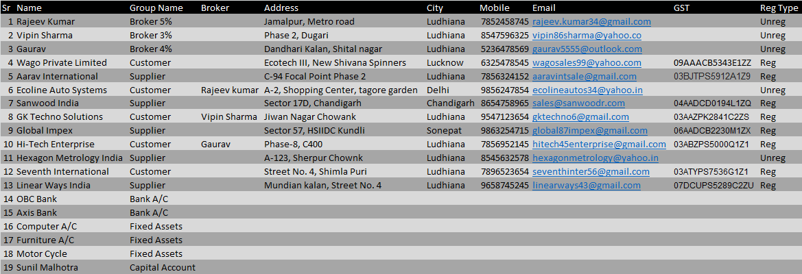
- Item Opening

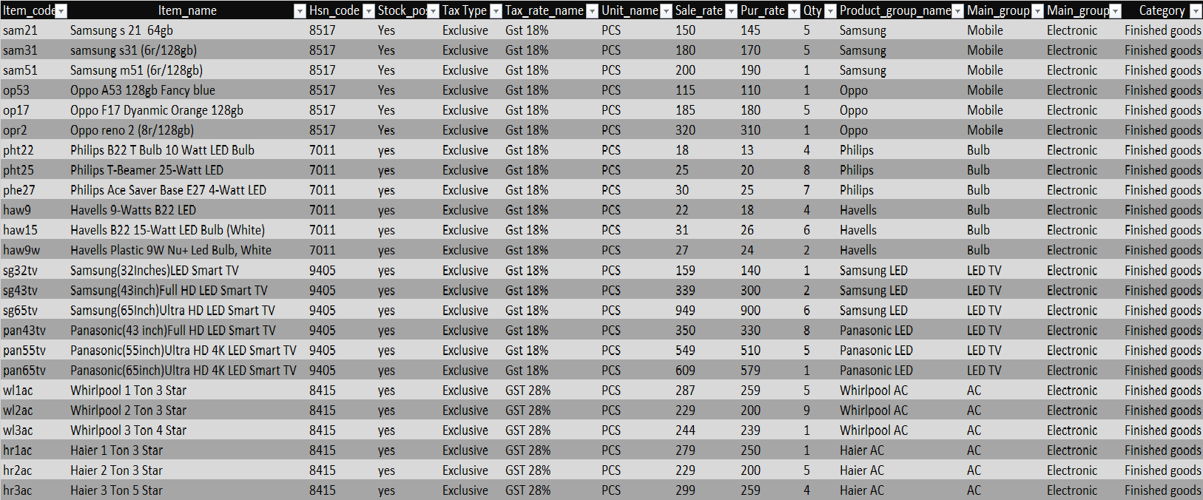

- Transactions
- Purchase from Aarav International 1-April-2021
Samsung s 21 64gb qty : 5 PCS rate : 145/-
Samsung s31 (6r/128gb) qty : 9 PCS rate : 170/-
Samsung m51 (6r/128gb) qty : 5 PCS rate : 190/-
Oppo A53 128gb Fancy blue qty : 12 PCS rate : 110/-
Oppo reno 2 (8r/128gb) qty : 2 PCS rate : 310/-
Oppo F17 Dyanmic Orange 128gb qty : 2 PCS rate : 180/-

- Purchase from Sanwood India 2- April-2021
Philips B22 T Bulb 10 Watt LED Bulb qty : 10PCS rate : 13/-
Philips T-Beamer 25-Watt LED qty : 5 PCS rate : 20/-
Philips Ace Saver Base E27 4-Watt LED qty : 1 PCS rate : 25/-
Havells 9-Watts B22 LED qty : 3 PCS rate : 18/-
Havells B22 15-Watt LED Bulb (White) qty : 5 PCS rate : 26/-
Havells Plastic 9W Nu+ Led Bulb, White qty : 5 PCS rate : 24/-

- Purchase from Hexagon Metrology India 3- April-2021
Whirlpool 1 Ton 3 Star qty : 6 PCS rate : 259/-
Whirlpool 2 Ton 3 Star qty : 1 PCS rate : 200/-
Whirlpool 3 Ton 4 Star qty : 3 PCS rate : 239/-
Haier 1 Ton 3 Star qty : 3 PCS rate : 250/-
Haier 2 Ton 3 Star qty : 10 PCS rate : 200/-
Haier 3 Ton 5 Star qty : 2 PCS rate : 259/-

- Sold to Hi-Tech Enterprise 4- April-2021
Whirlpool 2 Ton 3 Star qty : 5 PCS rate : 229/-
Haier 3 Ton 5 Star qty : 2 PCS rate : 299/-
Whirlpool 3 Ton 4 Star qty : 3 PCS rate : 244/-
Haier 2 Ton 3 Star qty : 5 PCS rate : 229/-

- Sold to Wago private Limited 5- april-2021
Samsung s31 (6r/128gb) qty : 5 PCS rate : 180/-
Samsung m51 (6r/128gb) qty : 2 PCS rate : 200/-
Oppo A53 128gb Fancy blue qty : 4 PCS rate : 115/-
Oppo reno 2 (8r/128gb) qty : 2 PCS rate : 320/-

- Sold to Ecoline Auto Systems 6- April-2021
Philips B22 T Bulb 10 Watt LED Bulb qty : 5 PCS rate : 18/-
Philips Ace Saver Base E27 4-Watt LED qty : 1 PCS rate : 30/-
Havells 9-Watts B22 LED qty : 1 PCS rate : 22/-
Havells B22 15-Watt LED Bulb (White) qty : 5 PCS rate : 31/-

- Sale Return from Ecoline Auto Systems 7- April-2021
Philips B22 T Bulb 10 Watt LED Bulb qty : 3 pcs rate : 18/-
Havells B22 15-Watt LED Bulb (White) qty : 2 PCS rate : 31/-

- Purchase Return to Sanwood India 8-April-2021
Philips B22 T Bulb 10 Watt LED Bulb qty : 3 pcs rate : 13/-
Havells B22 15-Watt LED Bulb (White) qty : 2 PCS rate : 26/-
- Purchase Return to Aarav International 9- April-2021
Samsung s 21 64gb qty : 2 PCS rate : 14/-
Oppo A53 128gb Fancy blue qty : 5 PCS rate : 11/-

- Cheque Paid from Axis to Aarav International (Cheque No. 102563) Amount : 4000 10-April-2021
- Cash Paid to Sanwood India Amount : 553 11-April-2021
- Cheque Paid from Axis Bank to Hexagon Metrology India(Chq No. 874596)Amount : 6000 12- April-2021
- Cheque Receive from Wago Private Limited (Cheque No. 785964, OBC Bank) Amount : 1000 13-April -2021
- Cash Receive from Ecoline Auto system Amount : 213 14- April-2021
- Cash Receive from Wago Private Limited Amount : 550 15- April-2021
- Cheque Receive from Hi-Tech Enterprise (Cheque No. 452136, Axis Bank) Amount : 2000 16-April-2021
- Cash Receive from Hi-Tech Enterprise Amount : 1000 17-April-2021
- Purchase from Global Impex 22- April-2021

Samsung(32Inches)LED Smart TV qty : 8 pcs rate : 140/-
Samsung(43inch)Full HD LED Smart TV qty : 6 pcs rate : 300/-
Samsung(65Inch)Ultra HD LED Smart TV qty : 1 pcs rate : 900/-
Panasonic(43 inch)Full HD LED Smart TV qty : 5 pcs rate : 330/-
Panasonic(55inch)Ultra HD 4K LED Smart TV qty : 3 pcs rate : 510/-
Panasonic(65inch)Ultra HD 4K LED Smart TV qty : 2 pcs rate : 579/-

- Purchase from Linear Ways India 24-April-2021

Whirlpool 1 Ton 3 Star qty : 2 PCS rate : 259/-
Whirlpool 3 Ton 4 Star qty : 4 PCS rate : 239/-
Haier 1 Ton 3 Star qty : 2 PCS rate : 250/-
Haier 3 Ton 5 Star qty : 3 PCS rate : 259/-

- Sold to GK Techno Solutions 25-April-2021
Samsung(32Inches)LED Smart TV qty : 6 pcs rate : 159/-
Panasonic(43 inch)Full HD LED Smart TV qty : 3 pcs rate : 350/-
Samsung(43inch)Full HD LED Smart TV qty : 5 pcs rate : 339/-
Panasonic(55inch)Ultra HD 4K LED Smart TV qty : 3 pcs rate : 549/-
Panasonic(65inch)Ultra HD 4K LED Smart TV qty : 2 pcs rate : 609/-

- Sold to Seventh International 26-April-2021
Whirlpool 1 Ton 3 Star qty : 5 PCS rate : 287/-
Whirlpool 3 Ton 4 Star qty : 4 PCS rate : 244/-
Haier 1 Ton 3 Star qty : 3 PCS rate : 279/-
Haier 3 Ton 5 Star qty : 3 PCS rate : 299/-

- Sale Return from GK Techno Solutions 28-April-2021
Panasonic(65inch)Ultra HD 4K LED Smart TV qty : 2 pcs rate : 609/-
Panasonic(55inch)Ultra HD 4K LED Smart TV qty : 3 pcs rate : 549/-
Samsung(32Inches)LED Smart TV qty : 3 pcs rate : 159/-

- Purchase Return to Global Impex 29-April-2021
Samsung(32Inches)LED Smart TV qty : 3 pcs rate : 140/-
Panasonic(55inch)Ultra HD 4K LED Smart TV qty : 3 pcs rate : 510/-
Panasonic(65inch)Ultra HD 4K LED Smart TV qty : 2 pcs rate : 579/-

- Cheque Paid from OBC to Global Impex (Cheque No. 878956) Amount : 3000 01-May-2021

- Cheque Paid from Axis Bank to Linear Ways India (Cheque No. 896956) Amount : 1000 2-May-2021

- Cash Receive from GK Techno Solutions Amount : 550 03-May-2021

- Cheque Receive from GK Techno Solutions (Cheque No. 541287, Axis Bank) Amount : 1500 04-May-2021

- Cash Paid to Global Impex Amount : 1000 05-May-2021

- Cash Paid from Linear Ways India Amount : 1000 06-May-2021

- Cheque Receive from Seventh International (Cheque No. 531587,OBC Bank) Amount : 2000 07-May-2021

- Cash Receive from Seventh International Amount : 1000 08-May-2021

- Reporting Upto 10-Mar-2021
- Check Stock in Hand
- Check Sale/Purchase Register Bill wise
- Closing stock type
- Sale purchase register bill wise
- Dues analysis bill wise detail
- Dues analysis payable detail
- Receivable (Debtors List)
- Payable (Creditor List )
Check all Parties ledger
- Check Ledger of Linear Ways India 2000 Dr = 3521 Cr Balance = 1521 Cr
- Check Ledger of Seventh International 5306 Dr = 3000 Cr Balance = 2306 Dr
- Check Ledger of Aarav International 4991 DR = 6496 Balance = 1505Cr
- Check Ledger of Wago Private Limited 2832 Dr = 1550 Cr Balance =1282 Dr
- Check Ledger of Sanwood India 660 Dr = 660 Cr = Balance = Nil
- Check Ledger of Ecoline Auto System 350 Dr = 350 Cr = Balance = Nil
- Stock valuation MRP 23990 Amount
- Closing Stock Amount 23990 amount. Closing date 1-04-2021 To 31-05-2021.
- Check income Statement 18884 Profit
- Check Trial Balance = 38115
- Check Trading Account
GST Purchase A/c 22712/-
Sale Return A/c 3458/-
GST Sale A/c 17026/-
Purchase Return A/c 4039/-
- Check Profit & Lose Account 18884 Profit
- Check Balance Sheet 35934 Amount

